Project Design Phase
Solution Architecture
Date | 08 October 2026
Team ID | 9100Smartgirls
Project Name | Streamlining IT Procurement: Automating Standard Laptop Orders with Flow Designer
Maximum Marks | 4 Marks

Solution Architecture:
Solution architecture bridges the gap between the business problem and the technology solution. For this project, the goals are:
Find a suitable ServiceNow solution for the manual standard laptop procurement and configuration problem.
Describe the structure, characteristics and behaviour of the solution to project stakeholders.
Define the features, development phases and solution requirements.
Provide specifications according to which the solution is defined, managed and delivered.
Solution Architecture Diagram:
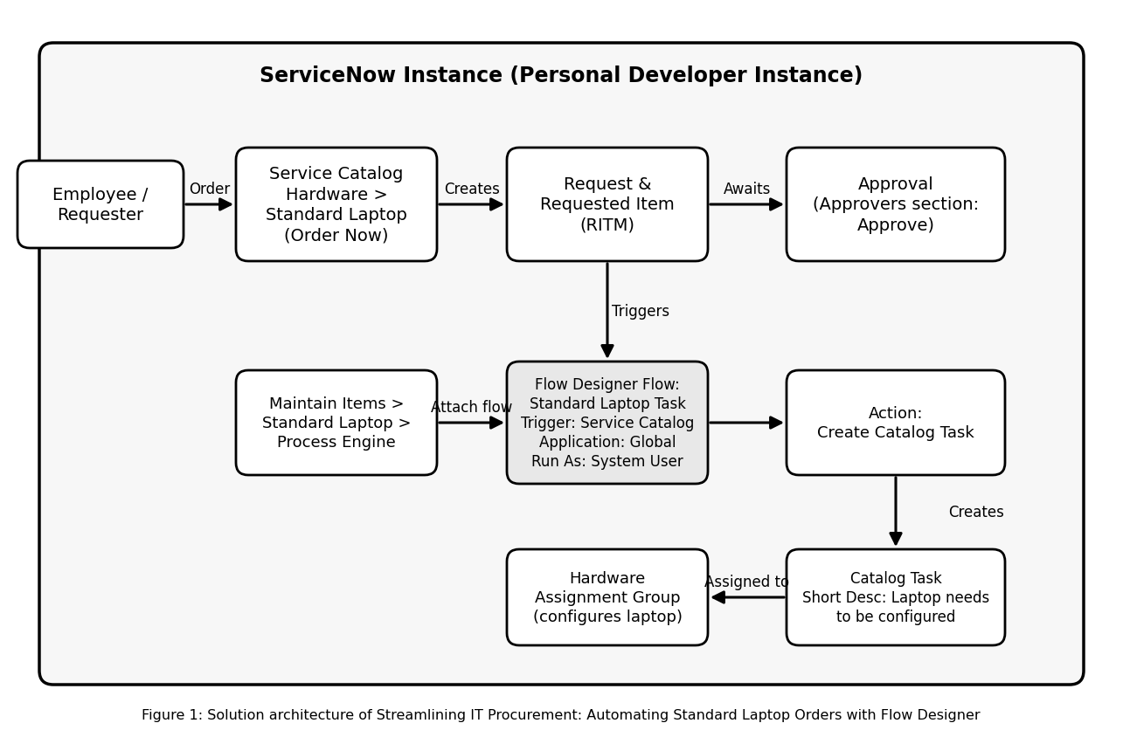
Description of the architecture:
Service Catalog and Standard Laptop item: the user opens Service Catalog, selects Hardware, opens Standard Laptop and clicks Order Now. A Request and a Requested Item (RITM) are created and the order status can be viewed.
Approval: the request is approved from the Approvers section of the Request record. Approval of the request lets the flow create the configuration task.
Flow Designer flow: the flow "Standard Laptop Task" (Application: Global, Run As: System User) has the Service Catalog trigger. The Create Catalog Task action uses the Requested Item record, sets Short Description and Description to "Laptop needs to be configured", sets Assignment Group to Hardware and Approval to Approved.
Process Engine and Catalog Task: through Maintain Items, the Standard Laptop record is linked to the flow using Process Engine. The resulting Catalog Task appears under the Requested Item and is assigned to the Hardware group for configuration.
Reference: https://docs.servicenow.com

